**ECE102 Lecture 22 simulation results**

1. **Asynchronous reset**

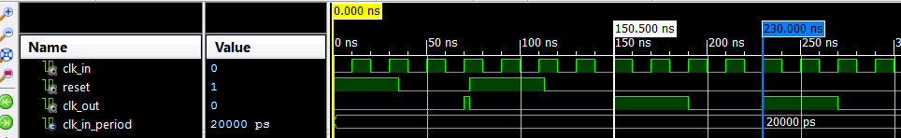

----------------------------------------------------------------------------------

library IEEE;

use IEEE.STD_LOGIC_1164.ALL;

entity clk_div_top is

Port (

reset : in std_logic;

clk_in : in STD_LOGIC;

clk_out : out STD_LOGIC);

end clk_div_top;

architecture Behavioral of clk_div_top is

signal clk_temp : std_logic;

---- internal signal: clk_temp

----Question: why do you need an internal signal?

signal count : integer range 0 to 15 :=0;

----32-bit count (default).

-----Question: Why do you specify the range?

begin

process(clk_in,reset,count)

begin

---- case #1 : Asychronous reset

if (reset = '1') then---- reset condition is HIGH

clk_temp <= '0';

count <= 0; ---reset the counter

----rising edge ====== active edge of clk_in

elsif (clk_in = '1' and clk_in'event) then

count <= count + 1; --- update the counter

if (count = 1) then

----Question: the conditional checking is based on past value or current value of count?

----Question: what's the frequency of clk_temp?

---- count = N ==> fclk/2*(N+1)

clk_temp <= not clk_temp;

count <= 0; ---- reset the count to zero every half cycle of clk_temp

end if;

end if;

end process;

clk_out <= clk_temp;

end Behavioral;

1. **Synchronous reset**

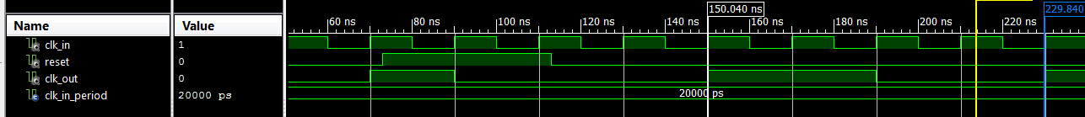

----------------------------------------------------------------------------------

library IEEE;

use IEEE.STD_LOGIC_1164.ALL;

entity clk_div_top is

Port (

reset : in std_logic;

clk_in : in STD_LOGIC;

clk_out : out STD_LOGIC);

end clk_div_top;

architecture Behavioral of clk_div_top is

signal clk_temp : std_logic;

---- internal signal: clk_temp

----Question: why do you need an internal signal?

signal count : integer range 0 to 15 :=0;

----32-bit count (default).

-----Question: Why do you specify the range?

begin

process(clk_in,reset,count)

begin

----- case #2 : syncrhonous reset

----rising edge ====== active edge of clk_in

if (clk_in = '1' and clk_in'event) then

if (reset = '1') then

clk_temp <= '0';

count <= 0;

else

count <= count + 1;

if (count = 1) then -----

clk_temp <= not clk_temp;

count <= 0;----reset the counter to 0

end if;

end if;

end if;

end process;

clk_out <= clk_temp;

end Behavioral;